Best Practices Website
General User Guide

July 2019

Table of Contents
1. Introduction 3
2. General Use 3
3. Searching Best Practices 3
  - Hide/Unhide Element Display 3
  - All Best Practices 3
  - By Number 3
  - By Text 4
  - By Category 4
  - By Industry Roles 4
  - By Network Types 4
  - By Keywords 4
  - Multiple Selections 4
  - Reset 4
  - Modify Search 4
4. Viewing Results 5
5. Searching Within Results 6
6. Exporting Results 7
7. System Access 7
  - Account Access 7

Introduction
This User Guide provides instructions for the general user on how to operate and navigate the ATIS Best Practices website.

General Use
A user account is not required to search, view, or export Best Practices.

Searching Best Practices
Best Practices can be searched by number, text, category, industry roles, network types, and/or keywords. The system allows a user to select one or more of the elements and multiple options within an element. The system will return Best Practices that contain all the options selected. In other words, the system uses an “and” statement, not an “or” statement. Selecting few elements or options will return the greatest number of Best Practices, selecting more elements or options will return fewer Best Practices.
Once the user selects the elements and options, pressing either the “Search” or “Enter” key will initiate a search.

Hide/Unhide Element Display
The user can hide or display the options of Industry Roles, Network Types, and Keywords by selecting the “+” or “-” sign on the right side of the element’s heading.

All Best Practices
To retrieve all Best Practices, ensure that both categories “Standard” and “Public Safety & Disaster” are checked, and select Search. By default, both categories are selected.

By Number
Any portion of the Best Practice number can be entered in the “By Number” field and the system will return the appropriate Best Practices. Following are examples of searches and returns:
- Search “0507”; system will return Best Practice ending in 0507
- Search “10”; system will return BPs that have “10” in any portion of the Best Practice Number (e.g. 11-10-5555, 11-11-1014, etc.)

By Text
Any portion of text a Best Practice may be entered in the “By Text” field and the system will return the Best Practices that contain that portion of text in the Best Practice Description field.

By Category
The user should select the category for which they wish to search. By default, both categories, “Standard” and “Public Safety & Disaster”, are selected. To search for a specific category, check the appropriate box. Definitions of the Categories will appear when hovering your cursor over the information icon.

By Industry Roles
The user should select the Industry Roles for which they wish to search. Selecting multiple options will return Best Practices that contain all the Industry Roles selected. Definitions of the Industry Roles will appear when hovering your cursor over the information icon.

By Network Types
The user should select the Network Types for which they wish to search. Selecting multiple options will return Best Practices that contain all the Network Types selected. Definitions of the Network Types will appear when hovering your cursor over the information icon.

By Keywords
The user should select the Keywords for which they wish to search. Selecting multiple options will return Best Practices that contain all the Keywords selected. Definitions of the Keywords will appear when hovering your cursor over the information icon.

Multiple Selections
The user can select multiple elements to search as well as multiple options within an element.

Reset
The user can clear all search parameters by selecting “reset”. This will allow new elements to be selected for new search results.

Modify Search
The user can modify the search parameters by selecting “modify search”. This will retain all the existing elements in the most current search and allow those same elements to be removed for the next search as well as new elements and options selected for new search results.

Viewing Results
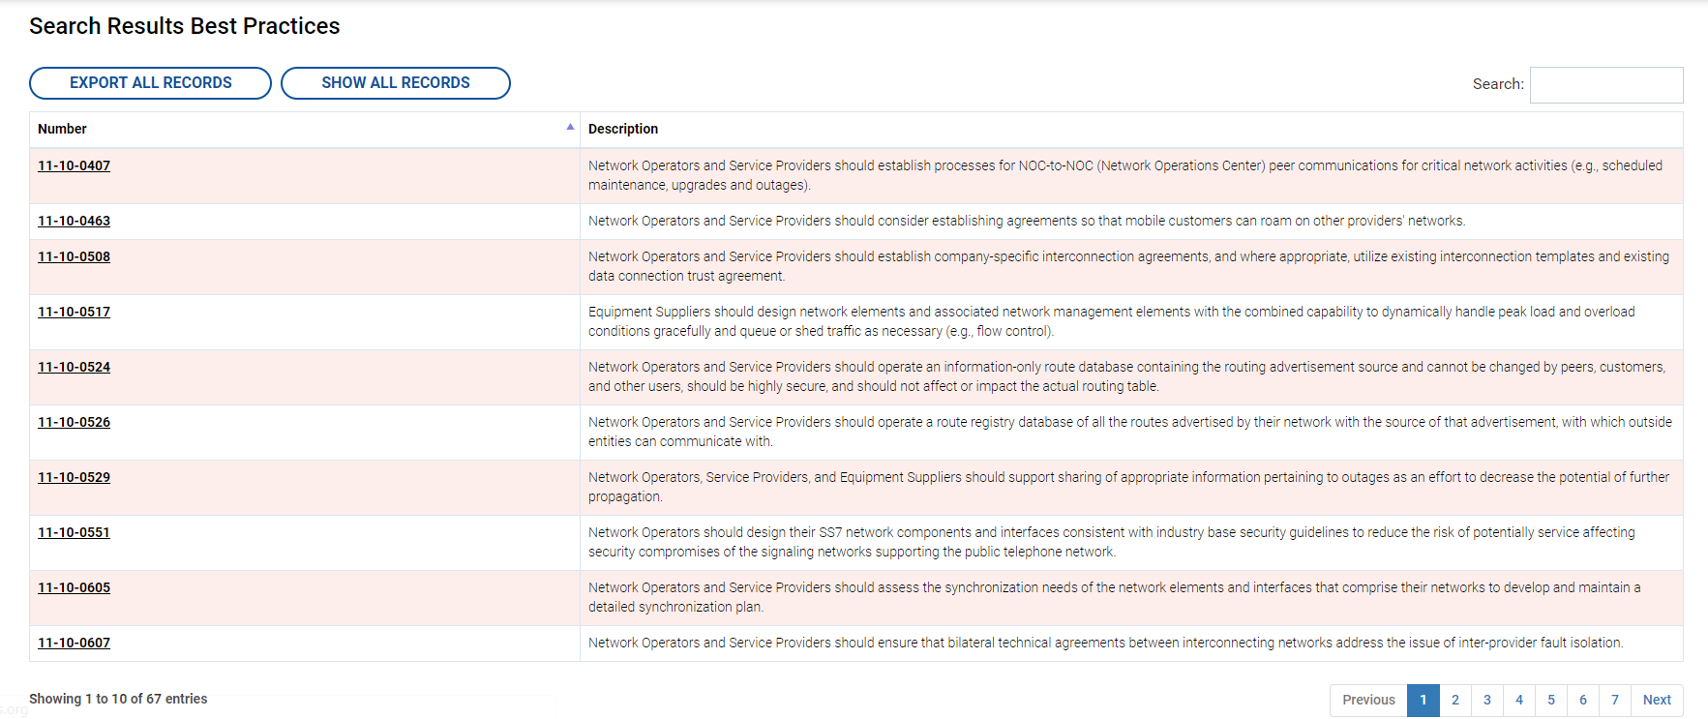
After a search is performed, the system will return Best Practices that match the number, text, category, industry roles, network types, and/or keywords selected, as displayed below.

The system may generate several pages of results. Select “Show All Records”, as shown below, to view all search results on the same page.
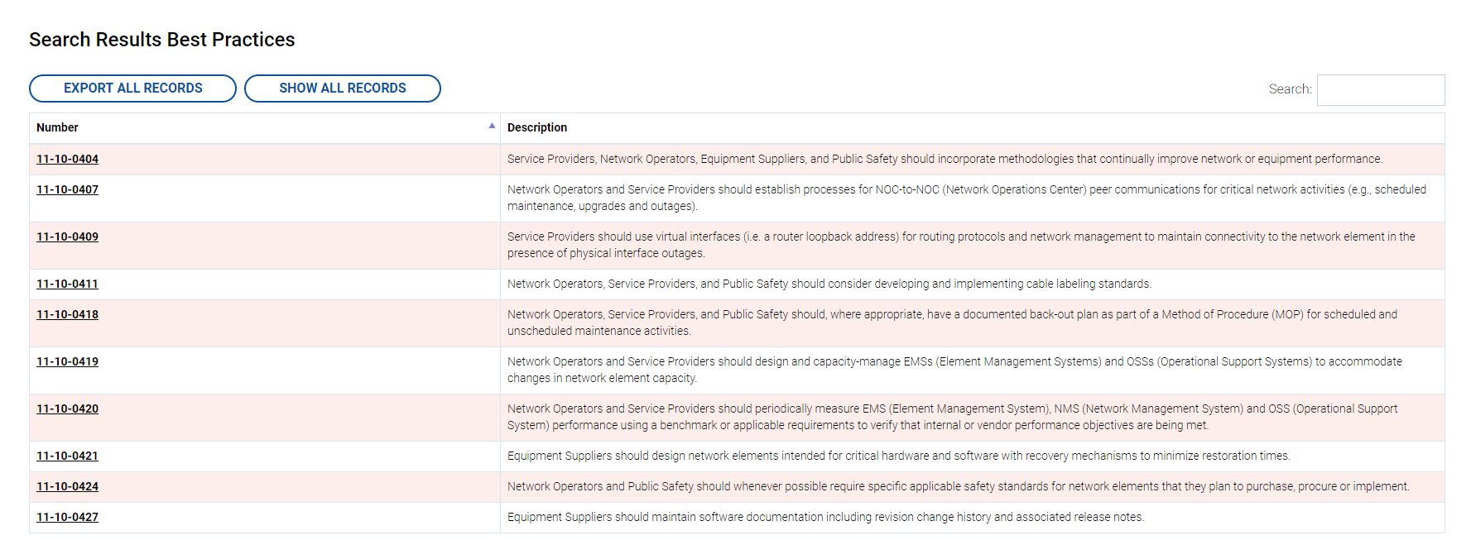

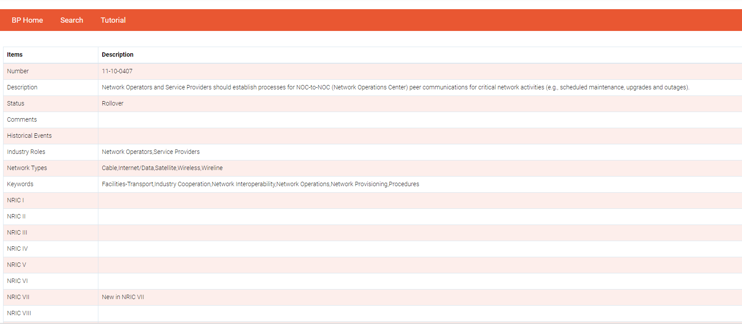
To view the specific details of each Best Practice, select the Best Practice Number. This will open a new page containing the Best Practice details:

5. Searching Within Results
This functionality allows the user to further refine an initial search. Once search results are returned by the system, the user can further search within a given set of results for specific keywords.
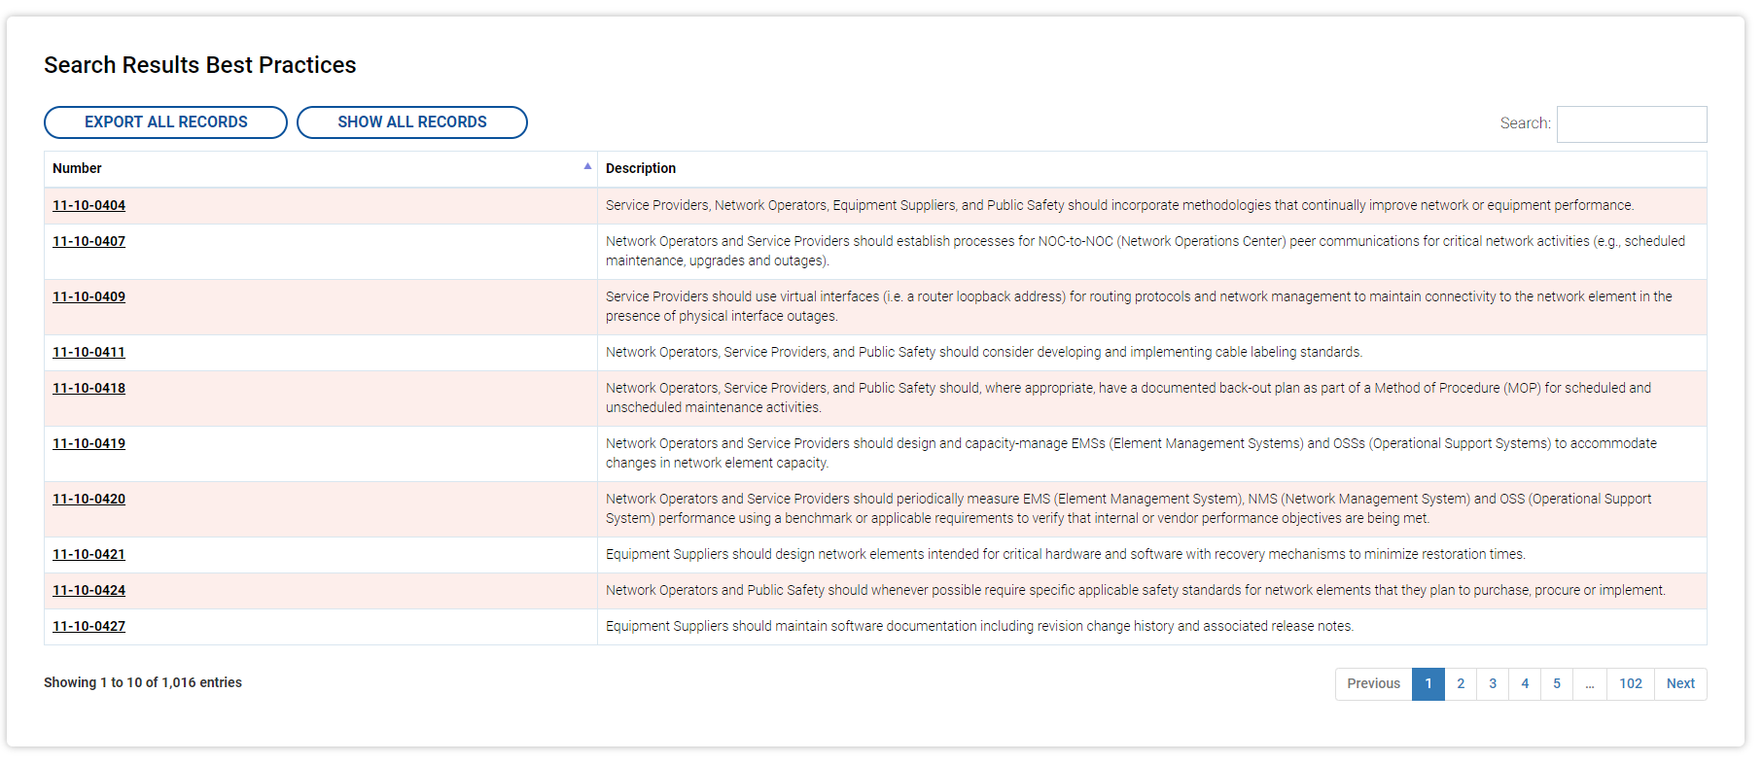
For example, if the user desires to find Best Practices related to hurricanes where the Industry Role is Public Safety, the user can search on Best Practices with the Industry Role of Public Safety by selecting the Public Safety in the initial search. Then, the user can further narrow that search by entering “hurricane” in the search bar that appears when the initial search results are provided.

6. Exporting Results
After a search has been performed, select “Export All Results” to export an excel spreadsheet of the results of the search.

To export all Best Practices, perform a search where both “Standard” and “Public Safety & Disaster” are selected and export the results of the search.

7. System Access

Account Access
The website requires a user account in order to propose new Best Practices, propose modifications to existing Best Practices, or recommend the deletion of Best Practices.
It is desired that a representative from each CSRIC WG establish an account in order to make Best Practice submissions. A user must contact ATIS in order to establish an account. Requests for accounts should be sent to jwohlgemuth@atis.org. The user should provide the WG they represent as well as a desired Username. The user will receive an email once their account is established.
A separate user guide has been developed for those who have established user accounts (typically, CSRIC representatives). This user guide can be accessed at https://bp.atis.org/userguides.

